**Project Design Phase-II**

**Technology Stack (Architecture & Stack)**

|  |  |
| --- | --- |
| Date | 31 October 2022 |
| Team ID | PNT2022TMID22148 |
| Project Name | Project – Smart Fashion Cloud Application Development |
| Maximum Marks | 4 Marks |

**Technical Architecture:**

The Deliverable shall include the architectural diagram as below and the information as per the table1 & table 2

**Example: To address the problem of user specific clothing image recommendation to advance an active learning scheme during retrieval for inferring user preferences.**

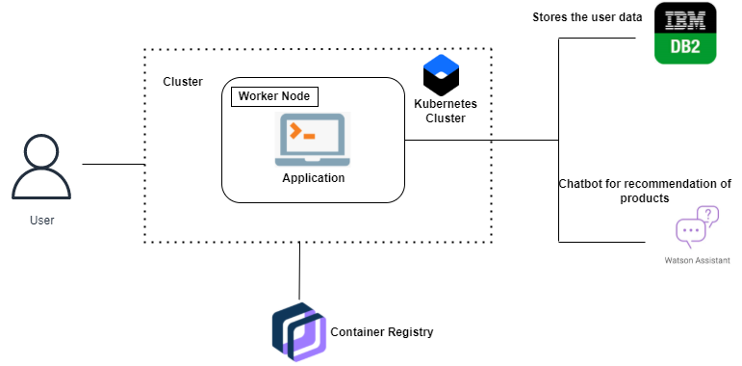

Guidelines:

1. Include all the processes (As an application logic / Technology Block)
2. Provide infrastructural demarcation (Local / Cloud)
3. Indicate external interfaces (third party API’s etc.)
4. Indicate Data Storage components / services
5. Indicate interface to machine learning models (if applicable)

**Table-1 : Components & Technologies:**

|  |  |  |  |
| --- | --- | --- | --- |
| **S.No** | **Component** | **Description** | **Technology** |
|  | User Interface | How user interacts with application e.g.  Web UI, Mobile App, Chatbot etc. | HTML, JavaScript |
|  | Application Logic-1 | Logic for a process in the application | Python – Flask, IBM cloud, kubernetes |
|  | Application Logic-2 | Logic for a process in the application | IBM cloud object storage, Docker |
|  | Application Logic-3 | Logic for a process in the application | IBM DB2, IBM container registry |
|  | Database | Data Type, Configurations etc. | MySQL, NoSQL, etc. |
|  | Cloud Database | Database Service on Cloud | IBM DB2, IBM Container registry, IBM cloud object storage. |
|  | File Storage | File storage requirements | IBM Block Storage or Other Storage Service or Local Filesystem |
|  | External API-1 | Purpose of External API used in the application | IBM (content based filtering) API, etc. |
|  | External API-2 | Purpose of External API used in the application | chatbot -Allows the user to communicate their preferences |
|  | Infrastructure (Server / Cloud) | Application Deployment on Local System / Cloud  Local Server Configuration:  Cloud Server Configuration : | Cloud object storage, Kubernetes, etc. |

**Table-2: Application Characteristics:**

| **S.No** | **Characteristics** | **Description** | **Technology** |
| --- | --- | --- | --- |
|  | Open-Source Frameworks | List the open-source frameworks used | Python-flask,Kubernetes, Docker |
|  | Scalable Architecture | Justify the scalability of architecture (3 – tier, Micro-services) | IBM cloud object storage, IBM DB2. |
|  | Availability | Justify the availability of application (e.g. use of load balancers, distributed servers etc.) | IBM cloud server, IBM Container Registry. |
|  | Performance | Design consideration for the performance of the application (number of requests per sec, use of Cache, use of CDN’s) etc. | Chatbot-for managing the user’s choice, helps in collecting the customer’s feedback |